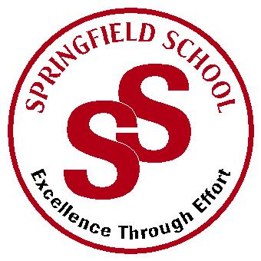
Springfield School
Crewe Green Road, Crewe, Cheshire CW1 5HS t: 01270 685446 f: 01270 258281

e: admin@springfield.cheshire.sch.uk www.springfield.cheshire.sch.uk

Headteacher: Lisa Hodgkison BA (Hons) | SEN SPECIALIST
 | SCHOOLS
Thursday, 13 May 2021

Dear Parents and Carers,
I am writing to inform you of forthcoming proposals to have an additional site for pupils who wish to attend Springfield School in the future.
As I am sure you are aware Springfield School is heavily oversubscribed with currently 180 pupils on role. Requests for places come to us daily, leaving disappointment and limited options for parents and their children when we are full.
We have been working with the Local Authority to explore options to create further provision for pupils within Cheshire East to accommodate pupils.
There are a number of options being considered at this time. One option for Springfield is to have a further site in Wilmslow, this would accommodate pupils living in the surrounding areas.
Please be assured this does not affect your child or the current Springfield site, the ‘satellite site’ would be for new admissions where we cannot allocate places here at Springfield Crewe. We are hoping to explore more options with Cheshire East over the next 6 months.
The attached letter gives you further information with regards the Local Authority position on their sufficiency plan for SEND within Cheshire East, including a link to share your views.

If you require any further information, please do not hesitate to contact me.

Your Sincerely
L Hodgkison

Lisa Hodgkison
Headteacher

