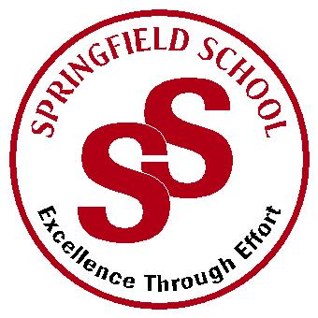**Springfield School**



Crewe Green Road, Crewe, Cheshire CW1 5HS t: 01270 685446 f: 01270 258281

e: admin@springfield.cheshire.sch.uk www.springfield.cheshire.sch.uk

|  |  |
| --- | --- |
| Headteacher: Lisa Hodgkison BA (Hons) | **SEN SPECIALIST** |
|  | **SCHOOLS** |



Wednesday, 11 November 2020

Dear Parents and Carers,

I hope you are all keeping well and enjoyed a break at half term. In light of the recent Government announcements we have been reviewing all of our policy and procedures over the last week.

After some consideration with the new guidance set out by the DfE we are happy to report minimal changes are required. We continue to deliver a full curriculum with pupils working within their bubbles. Bubble working is proving successful and allowing all pupils to access the curriculum at an appropriate level.

We continue to monitor the ever-changing scene and ensure a safe a positive environment for all pupils. Full details of the risk assessments can be found at [www.springfield.cheshire.sch.uk](http://www.springfield.cheshire.sch.uk)

**What to do if your child develops symptoms of COVID-19**

*If your child develops symptoms of COVID-19, they must not come to school and should remain at home for at least 10 days from the date when their symptoms appeared.*

*Anyone with symptoms will be eligible for testing and this can be arranged via* [*https://www.nhs.uk/ask-for-a-coronavirustest or by calling 119*](https://www.nhs.uk/ask-for-a-coronavirustest%20or%20by%20calling%20119)*.*

*All other household members who remain well, must stay at home and not leave the house for 14 days. This includes anyone in your ‘Support Bubble’.*

*Further information is available at: https://www.gov.uk/government/publications/covid-19-stay-athome-guidance/stay-at-home-guidance-for-households-with-possible-coronavirus-covid-19- infection The 14-day period starts from the day when the first person in the house became ill.*

**Christmas**

We have started to focus on our Christmas programme ready for December in conjunction with the Friends of Springfield, although it may look a little different this year our goal is to still celebrate in the usual Springfield fashion! Please take a look at the Friends of Springfield Facebook page which will give you further information on the Virtual Christmas Market - <https://www.facebook.com/groups/979020902608985>

If you do have any questions and concerns, please let us know at your earliest convenience and we will endeavour to support and help.

Kind Regards

Lisa

Lisa Hodgkison

Headteacher